GROUP MEMBERS: Bindu van Raak (611629)

Justin Mulder (563558)

Assem Abdellaoui (566456)

Justice Pandt (580014)

Joud Beniamin (617059)

Group 2 Project Report

Version 1.3

January 8, 2019

Table of Contents

Management Summary 2

1. Introduction 3

2. Context 4

2.1 Situation in the Organisation 4

2.2 Problem Statement 4

3. Goals of the project 5

3.1 Objectives 5

3.2 Main Research Question and Sub questions 5

Main Research Question 5

Sub Questions 5

4. Methodology 6

4.1 Research Strategy 6

4.2 Research Design 6

5. Results and analysis 7

6. Conclusion 13

7. Discussion 15

References 16

Appendix A 17

Appendix B 22

Appendix C 23

Appendix D 31

# Management Summary

////TODO////

# 1. Introduction

The purpose of this document is to provide a definition of the project, including this project’s goals and objectives. Additionally, this plan will serve as a contract between the group members.

The Project Report defines the following:

* Context of the situation
* Project goals and objectives
* Methodology of the project
* Results and analysis
* Conclusion
* Discussion

Chapter 2 will describe the context of the situation. There the needs of the client will be specified, and the problem will be stated. In chapter 3 the goals of the project will be outlined, describing the main objectives of the project. Also, the main research question and sub questions will be defined. In chapter 4 the methodology of the project will be explained. Here the research strategy and design will be further described. In chapter 5 the results will be outlined and analysed. In chapter 6 the main conclusions will be drawn and each question given a definitive answer. In chapter 7 the strengths, weakness and possible alternate interpretations of the results will be discussed. Lastly, the references and appendices will be stated.

# 2. Context

The Oostvaardersplassen is a closed nature reserve in the Netherlands. The area is home to many kinds of animals, the most prominent of which being large mammals. These large herbivores are supposed to have occurred in the Netherlands in the past and have helped shape the landscape. The general idea behind this nature reserve is to have the animals live as naturally as possible; for example, carcasses of dead animals will remain, and the animals are not fed in case of food shortages. However, this policy has led to animals starving and people seeing dead or suffering animals from the side of the road or train and feeling sorry for them. On the other hand, the general public protest when animals are shot to reduce the population and the strain on natural resources. There is no easy solution to this as every choice has its consequences.

## 2.1 Situation in the Organisation

Staatsbosbeheer, the organization owning the Oostavaardersplassen nature reserve, has asked Inholland University of Applied Sciences to develop an application which can predict the possible population given certain circumstances and thus give the best ethically acceptable solution to the problem. By building multiple mathematical models of real-life situations in order to make predictions, the application will be able to offer multiple options and conditions to calculate different theoretical solutions.

## 2.2 Problem Statement

In the Oostvaardersplassen nature reserve, three kinds of large herbivores are present: wild horses, wild cattle, and deer. Other major species are geese and birds of prey. As one can surmise from this, there are no major predators present. The ecological system in this nature reserve has been unbalanced from the beginning, partly due to the absence of a top predator and also due to the closed nature of the preserve, meaning the herbivores cannot migrate to new lands in search of food. This has caused overpopulation of these animals and this has led to animals starving, and the general public being very unhappy about this.

# 3. Goals of the project

## 3.1 Objectives

The objective of this project is to create an application which implements the necessary mathematical models which calculate the effects of certain conditions on the current situation and thus showing the best possible solution to the described problem.

## 3.2 Main Research Question and Sub questions

### Main Research Question

What is the best ethically acceptable measure which can be taken to improve the ecological balance in the Oostvaardersplassen?

### Sub Questions

The sub questions are as follows:

1. *What are the needs of the client?*
2. *What mathematical models are already available?*
3. *What variables should be taken into consideration when creating mathematical models?*
4. *Which models are simple enough to use with the data acquired?*
5. *How can the results of the models be displayed in an application?*

# 4. Methodology

## 4.1 Research Strategy

To finish this project, and approach will be taken that is more directed on a literature study. Most things which are needed to complete this project will be found in primary or secondary literature. However, there will be some descriptive research and some experiments undergone to help answer some of the sub questions. The depth of the research will be exploratory since it is setting out to discover the right solution to the described problem.

## 4.2 Research Design

In this section, we will go over each sub question and how we will answer them.

1. *What are the needs of the client?*

To answer this question, first a literature study will be carried out which focuses highly on the lessons of software engineering. During these lessons, the group will learn how to find the needs of a client and this knowledge will then be used to answer this question by means of a descriptive study. This will be qualitative research, as there will not be any numbers derived from it.

1. *What mathematical models are already available?*

This question will be answered by means of a literature study will be carried out on the provided books and previous projects. This will provide the group with the knowledge that previous project groups and/or researchers have already acquired which will in turn provide an answer to this question. This research will be quantitative as the existing mathematical models will merely be defined.

1. *What variables should be taken into consideration when creating mathematical models?*

To answer this question, a literature study will be carried out on the previously collected data. Then the models will have to be studied to understand which variables are to be used.

1. *Which models are simple enough to use with the data acquired?*

To discover how the models can be simplified, a literature study will be carried out on the models already acquired, along with some experiments to define what or how the models can be simplified. This research will be qualitative.

1. *How can the results of the models be displayed in an application?*

To find out how the results can be displayed in an application a qualitative literature study will be carried out on the previous classes of Object Oriented Programming and the current classes of UML. This will define what is possible to do in the time of this project. Some exploratory research will also be carried out to find out the best and most effective way of displaying the results of the models in the application.

# 5. Results and analysis

In this chapter, the results of each data collection step in this project will be outlined. Once the results are stated they will be analysed and intermediate conclusions will be drawn.

The sub questions are as follows:

1. *What are the needs of the client?*

To answer this question, first a literature study was carried out on the current context outlined in Chapter 2: Context. In these chapters it was found that the client’s requirements were stated quite clearly. The client needs an application that can predict the possible populations of certain species in the nature preserve at a certain time given certain circumstances. The application should thus provide the best ethically acceptable solution to the problem. The application should be able to offer multiple options and conditions to calculate different theoretical solutions to the problem at hand.

From there, a list was made with all the possible features that the application could have. However, this list was quite extensive, and implementing all of the features in the application could not be done within the given time frame. Therefore, a small structured interview was carried out with the client where they were asked to prioritise each feature using the MoSCoW method. That method working as follows: Divide the features between Must-haves (20%), Should-haves (20%), Could-have (30%) and Would-like-to-haves (30%).

The feature list, with the client’s added priorities, is as follows:

1. Project the predictions in a graph. M

The user can view the growth or decline of animal populations in a graph over a certain period.

1. Display results of different animals. M

The user can view the results of the calculations made for the main large herbivores as an individual species rather than the total number of large herbivores.

1. Switch between different mathematical models. S

There will be more than one calculation that can be made, so the user can make a choice of which type of calculation wanted can be specified.

1. Alter initial data, capacity and starting amount of each animal. S

As time goes on, the data of wildlife in the reserve will change, therefore the system administrator should be able to alter or update the data used in the application.

1. Predict future numbers of animals. C

The user can use the app to predict the possible number of animals after a specified time.

1. Toggle natural factors that may affect the outcome. C

The user can specify when to take certain natural factors into consideration when making a calculation/prediction. For example; temperature, grass growth and seasons etc. can all be considered or not.

1. Change type of graphs for projecting the results. C

The user can choose different graph options for example a pie chart, line chart or bar chart.

1. Store and load the results of a prediction to and from a file. W

After each calculation, the results are saved to a file so that they can be used later for other tasks such as comparisons with other outcomes and whether they are viable.

1. Store time/date of the calculations made. W

The user can state whether to provide the time and date of each calculation made. This makes it possible to go back and find specific previous calculations.

1. Customise graph colours. W

The user can choose different colours and styles on the application to make it fit to their liking.

After studying this prioritised feature list further, the following domain model was created:

/////ENTER DOMAIN MODEL HERE/////

Due to the scope of this project, only some features were implemented into an application, the detailed use-case descriptions of these user stories are shown in Appendix A.

1. *What mathematical models are already available?*

After conducting some literature research (both primary and secondary) using basically relevant online scholarly articles and the recommended books (see reference list) , plenty of possible mathematical models seamed to explain the ecological system and can be applied to the given context.. Here are some examples:

Let’s start first with the basic growth models which explain the growth and/or the extinction of the species:

**The Malthus model or exponential growth model:**

(1.1)

N(t) = (1.2)

Where r = b-d, and b and d are constant birth and death rate respectively.

The growth rate according to the exponential model is the same which means the bigger the population number, the faster and bigger it gets with time. Applying this formula using the given data of the animals would show an unrealistic exponential rise of their number represented by a J-shaped curve. (Figure 1) Which brings us to the next model.

**The Verhulst model or logistic growth model:**

(1.3)

(1.4)

In this equation, the bigger the population size N gets approaching the maximum carrying capacity K, the smaller the birth rate. Which makes sense since observations have shown that the large number of herbivores in the preserve has led to an unbalanced ecological system where the animals compete for food and facing starvation. It’s representation on the graph shows an S-shaped curve. (Figure 2)

Discrete population growth:

Model of Grass Growth:

GP =

Etc….

* N = the size of population
* t =point in time
* Nt =number of individuals in population at a certain time.
* B = num of birth
* D = num of death
* I = num of immigration (entering)
* E = num of emigrants (leaving)
* r = instantaneous or linear birth rate of increase = Birth-Death
* b = instantaneous birth rate [ birth / individual x time]
* d=instantaneous death rate [ death / individual x time]

1. *What variables should be taken into consideration when creating mathematical models?*

The following assumptions and considerations were taken for the sake of *simplification*:

* No genetic, age or size structure.
* There is no immigration or emigration since the fences are close.
* There is no predator effect even though releasing wolves would restore or at least improve the balance. Researchers discovered that the preserve couldn’t be big enough to contain a pack of wolves without affecting the eco-system balance and would be controversial anyway.
* Based on the project description, previous researches have shown that interactions between the deer and the other species is only 30% and could be left out.
* The growth rate is considered to be continuous 🡪 no time lags.

However ignoring these effects isn’t realistic as the observations show that the system is more complex and that many interacting factors affect this eco-balance. That’s why it’s wise to take into account the effect of some variations on the models, such as:

* The **exponential** growth isn’t realistic since the resources are limited, which influences the birth and death rates, that’s why the **logistic** formula was used instead.
* Time lags.
* Discrete population growth # Continuous model

1. *Which models are simple enough to use with the data acquired?*

**Simple logistic growth equation with limited resources (food supply):**

We can apply this model to deer which Have relatively less interaction with other species (30% according to previous researches mentioned in the project description)

* Age, genetic and size factors were ignored to avoid starting with a complex model and keep it simple.

The following assumptions was taken in consideration for this model:

* Fences are closed: no migration effect.

**The Lotka Volterra Model: interaction between large herbivores** (Cattle and horses which share almost the same territory)

and = Competition coefficients

**Model with migration effect (Simple metapopulation growth rate)**

Where:

* is the probability of local extinction
* is the probability of local colonisation
* **f** is the fraction of patches in occupied territory

Some model variations were dropped, and the following factors were taken in consideration:

* and are constant rates.
* No rescue effect or time lags.
* Homogeneity of patches.

1. *How can the results of the models be displayed in an application?*

Following the methodology for this question, a literature study was carried out on the current classes of UML as well as the previous classes and knowledge of Object-Oriented Programming. Using these classes, a solid architecture for the application could be put together. During the classes of UML, it was learned that there is a very thorough and structured process to designing and implementing an application.

Finding out how to display the results in an application was fairly easy; a formula would be used to calculate the populations of the different animals at a certain time, and from there these points would be plotted on a line graph. However finding the best way to do this proved difficult.

The first proof of concept used a system that was much too simplistic and could only project the results of one animal in a very simple graph. This system worked in a way that all animals were objects of the same class, that being a “Large Herbivore”. From there these LargeHerbivore objects would be used, in combination with a user-entered number of years, in a method which would return a series of points based on a certain formula. This series would then be projected in a graph. This design was used purely to get used to projecting points onto a graph, and it was already clear that this would not be the design used in the final product.

Finding the right design for the application was quite difficult, the classes of Object Oriented Programming were studied thoroughly and the instructors had to be consulted many times before it was crystal clear what the best course of action was to make the applications architecture as structured as possible. Through studying these classes, it was found that using design patterns to make the code more efficient, scalable and readable would prove to be very important when making the application. The design of the application is broadly outlined in the following paragraphs and the class diagram of the application is included in Appendix D to hopefully make the description more understandable.

To create the base of the application, the program SceneBuilder was used to design the way the application should look to a user. The most important features of this base layout being the graph which shows the increase or decrease of population of different animals and the table which shows the exact values at a certain time. To make the results be projected into the graph, a series of points for each animal would have to be created and displayed as a line on the graph and to show the exact values of each animal at a given time, the values of the animals and the selected time would also have to be displayed in a table.

How all of this was made not only possible, but also structured in a way that is the following. The first aspect of the design minimises the effort needed to add or remove different models from the application. The way this was achieved was by using the strategy design pattern to create an interface which defines a method that each mathematical model should have. From there, new classes can be created when a new mathematical model is designed and can be put in the place of any previous models without problems. This same design pattern was also used when creating animals. An abstract class was defined called “Large Herbivore” and from there a new class can be added extending this class if a new large herbivore should be added to the application. This allows for interchangeability between all of the large herbivores.

The next aspect of the application continues on from the mathematical model classes. To make selection of different models possible, a way to set the “active” model in the application had to be implemented. To make this possible, the Factory design pattern was used to set which mathematical model class should be used when making calculations. A Model Factory class was created, in which static methods set and get the selected model. This made it possible for the user to select which model to use.

Lastly, a class “NaturePreserve” was created using the singleton design pattern. In this class, the current time is stored as well as all of the animals and their current populations at said time. This class is what is used in the FXML controller to create different series’ of points for each animal in the preserve.

Using these design patterns, the architecture of the application is now very strong, and adding more mathematical models or species to the application can be done without having to change a lot in the code.

# 6. Conclusion

This chapter will draw the final conclusions to each of the sub questions and give an answer to the main research questions.

1. *What are the needs of the client?*

While following the methodology for this sub question, the literature study and interviews were very successful in finding and defining the needs of the client. In the scope of this project, the clients most important user stories were implemented into the application. Looking at the results, it can be stated that the needs of the client and the answer to this sub question is as follows:

The needs of the client are an application which can do the following:

1. *Project the predictions of animal populations in the future in a graph.*
2. *Display results of these predictions of different animals.*
3. *Switch between different mathematical models which make the calculations.*

1. *What mathematical models are already available?*

Mathematical models are already constructed and proven. There is no need to start from scratch. Finding the relevant ones and implementing them in the application wasn’t that easy though. Writing down all encountered math models in biology isn’t relevant but some of them were picked up to be selected later. Especially those that can be easily explored and used to describe the situation and predict the outcome in the best way possible.

1. *What variables should be taken into consideration when creating mathematical models?*

In this project mathematical tools are a necessary tool to make predictions and achieve results that can give solutions and answer the main question.

The problem is that the mathematical models can be complex and difficult to explore and implement in the application. Another problem is the big amount of the already constructed models, from which many formulas were deducted and that made it little vague and complicated to decide which ones to use. Referring to the situation and trying to understand it first and starting from simple understandable models leaving out some variations and making assumptions was an urgent strategy to avoid being overwhelmed with a lot of formulas and equations.

1. *Which models are simple enough to use with the data acquired?*

Starting from simple models and pre-conducted researches has helped simplifying the research and reducing the amount of data and equations needed to few simple formulas but useful and manageable though. However, the results found still have to be examined and applied to the real context and some influencing factors lead us to leave out some of them, especially if they turn to be not realistic and cannot explain the whole situation with its variations and correlation between the subsystems and the interactions and dependency within the system.

1. *How can the results of the models be displayed in an application?*

While following the methodology for this question, the literature studies on previous courses proved to be successful in coming to an answer. Looking back on the results, it is clear that the application is now very structured and very scalable and an answer to this sub question can now be stated.

The results can be displayed in an application by using design patterns to make the selection of different models possible. These models can then be used to create a series of points to be displayed on a graph. The time points on the graph can then be selected to display the exact results of each animal in a table to make recording them more effective.

***What is the best ethically acceptable measure which can be taken to improve the ecological balance in the Oostvaardersplassen?***

////TODO////

# 7. Discussion

In this chapter the strengths and weaknesses of the results will be discussed and other explanations covered.

////TODO////

# References

*Project Handbook: 1819 Project Description Application Development Year 2, Semester 1, 2018-2019*

*A Primer of Ecology* by Nicholas J. Gotelli, ISBN 978-0-87893-318-1.

# Appendix A

**Use Case – Project Predictions in Graph.**

**Primary Actor:** User

**Stakeholders and Interests:**

* User: Wants an accurate and easy to use application that will show them the effects of certain solutions to the unbalanced nature preserve problem.
* Company: an application which implements the necessary mathematical models which calculate the effects of certain conditions on the current situation and thus showing the best possible solution to the described problem.

**Precondition:** Prediction has been made.

**Postcondition:** There will be a graph representing the populations per year.

**Main Success Scenario (or Basic Flow):**

1. Application draws the lines for each animal in different colours.
2. Application projects the lines onto a XY line graph. (x = years, y = population)
3. User clicks on a certain point (year) on one of the lines.
4. Application presents the exact populations of each animal for the point (year) selected in step 3

**Extensions (or Alternative Flows):**

*a. At any time, System fails:

Assuming System crashes after clicking a line on the graph.

1. User closes the application and opens it again.
2. Application starts up.
3. User attempts the calculation again.

2a. Invalid value:

1. Application sends a pop-up message stating “Please insert a number greater than 0”.

**Use Case – Alter Initial Data**

**Primary Actor:** User

**Stakeholders and Interests:**

* User: Wants an accurate and easy to use application that will show them the effects of certain solutions to the unbalanced nature preserve problem.
* Company: an application which implements the necessary mathematical models which calculate the effects of certain conditions on the current situation and thus showing the best possible solution to the described problem.

**Precondition:**

**Postcondition:**

**Main Success Scenario (or Basic Flow):**

1. User clicks the “change initial data” button.
2. Application opens separate window with input boxes and an “ok” button.
3. User fills in the new initial data required and presses “ok”.
4. Application changes its initial data and closes the window created in step 2.

**Extensions (or Alternative Flows):**

*a. At any time, System fails:

Assuming System crashes after attempting to change initial data.

1. User closes the application and opens it again.
2. Application starts up.
3. User attempts to change the initial data once again.

2a. Invalid input:

1. Application presents a message in red-bold-font at the top of the window stating “One or more fields are invalid. Please insert a number greater than 0”.
2. User finds the insufficient input and inserts the proper changes.
3. Application changes its initial data and closes the change initial data window.

2b. Null Input:

1. A) Application makes no changes to its initial data and closes change initial data window.

B) User inserts 0 into a text field as input.

1. Application sends a pop-up message stating “Are you sure you meant 0, this is different to entering nothing”.

**Use Case – Predict Future Numbers Of Animals**

**Primary Actor:** User

**Stakeholders and Interests:**

* User: Wants an accurate and easy to use application that will show them the effects of certain solutions to the unbalanced nature preserve problem.
* Company: an application which implements the necessary mathematical models which calculate the effects of certain conditions on the current situation and thus showing the best possible solution to the described problem.

**Precondition: -**

**Postcondition:** An exact number of populations per animal will be projected and readable.

**Main Success Scenario (or Basic Flow):**

1. User fills in the required values into the textboxes and presses “calculate”.
2. Application calculates a prediction using the default/selected mathematical model.
3. Application presents the predicted results of future populations.

**Extensions (or Alternative Flows):**

*a. At any time, System fails:

Assuming System crashes after a calculation had been attempted.

1. User closes the application and opens it again.
2. Application starts up.
3. User attempts the calculation again.

2a. Invalid input:

1. Application sends a pop-up message stating “Please insert a number greater than 0”.
2. User presses “ok” button.
3. Application closes pop-up window.

3a. Switching between mathematical models:

1. User clicks on the model menu button.
2. Application offers a list of math models in drop down menu.
3. User selects the required mathematical model.
4. Application switches the page.
5. Application waits for the input of the values suitable to the selected model.

3b. Using the new model:

1. User fills in the required values into the textboxes and presses “calc”.
2. Application calculates a prediction using the selected mathematical model.
3. Application presents the predicted results of future populations.

**Use Case – Store and load the results of a prediction to and from a file**

**Primary Actor:** User

**Stakeholders and Interests:**

* User: Wants an accurate and easy to use application that will show them the effects of certain solutions to the unbalanced nature preserve problem.
* Company: an application which implements the necessary mathematical models which calculate the effects of certain conditions on the current situation and thus showing the best possible solution to the described problem.

**Precondition:** Prediction has been made.

**Postcondition:** A record of your saved predictions will be found on your computer as a text file.

**Main Success Scenario (or Basic Flow):**

1. User clicks the “change initial data” button.
2. Application opens pop-up window with an input boxes and an “ok” button.
3. Application asks for the path you would like to store the prediction.
4. Application waits for user input.
5. User fills in his preferred path and presses “ok”.
6. Application creates the file and adds the prediction to the file.

**Extensions (or Alternative Flows):**

*a. At any time, System fails:

Assuming System crashes after attempting to change initial data.

1. User closes the application and opens it again.
2. Application starts up.
3. User attempts to store the prediction once again.

2a. Invalid path:

1. Application presents a message in red-bold-font at the top of the pop-up window stating “Path cannot be found, try again”.
2. User changes path to the desktop.
3. Application creates the file and stores the prediction to the desktop.

# Appendix B

**Population Growth Rate**

Figure 1: Exponential Growth

Figure 2: Exponential vs Logistic Growth

# Appendix C

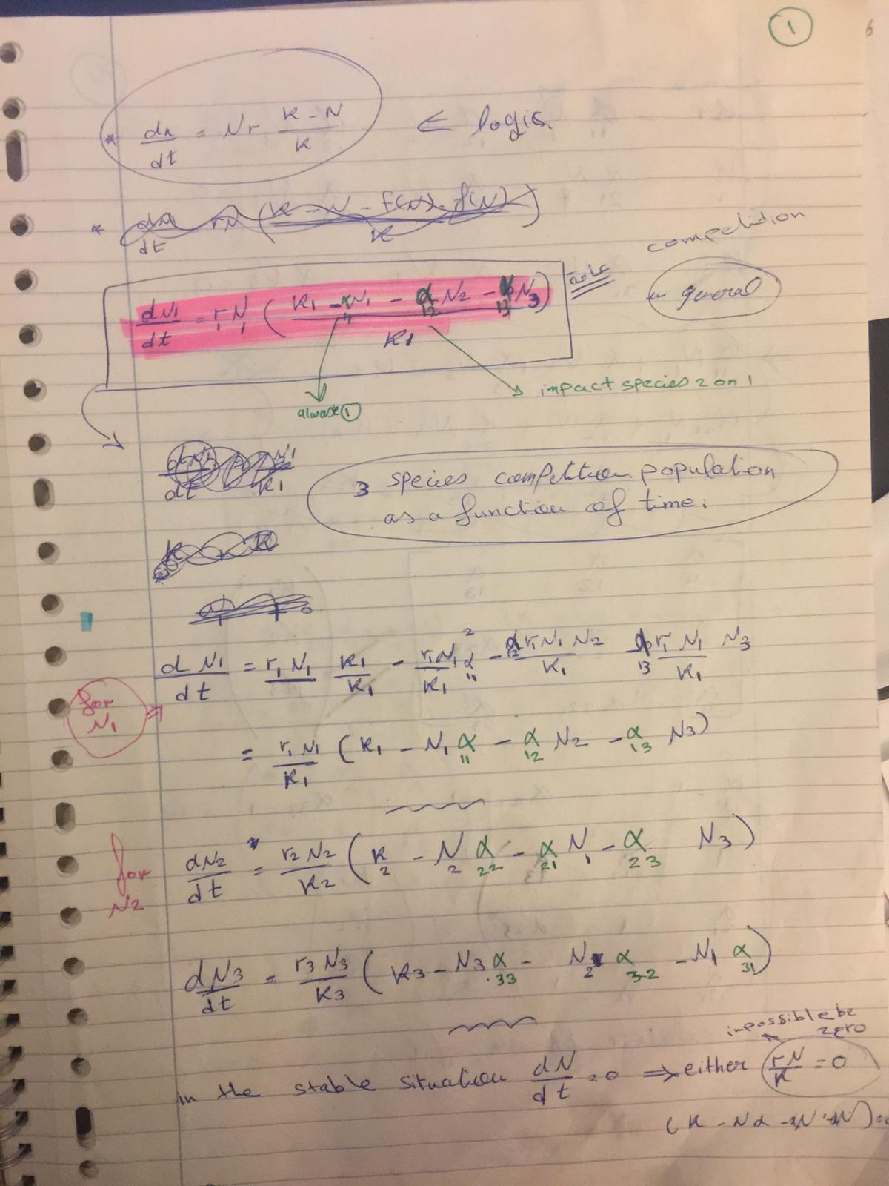**Drafts of Mathematical Equations**

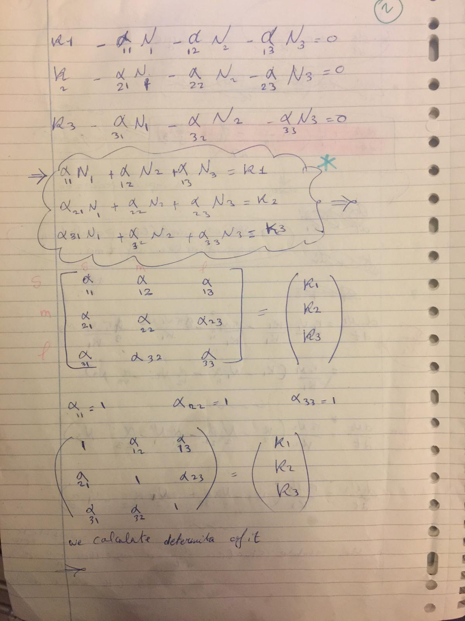

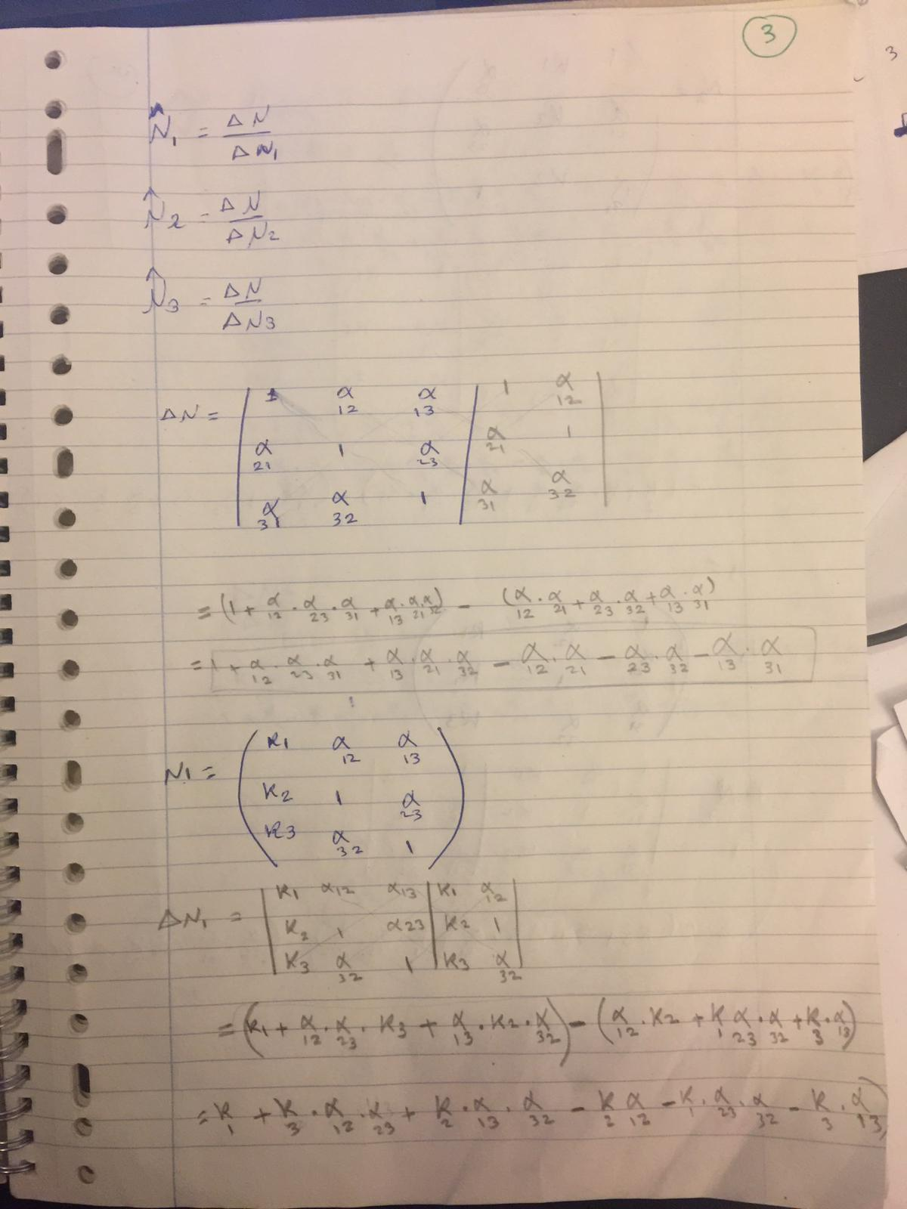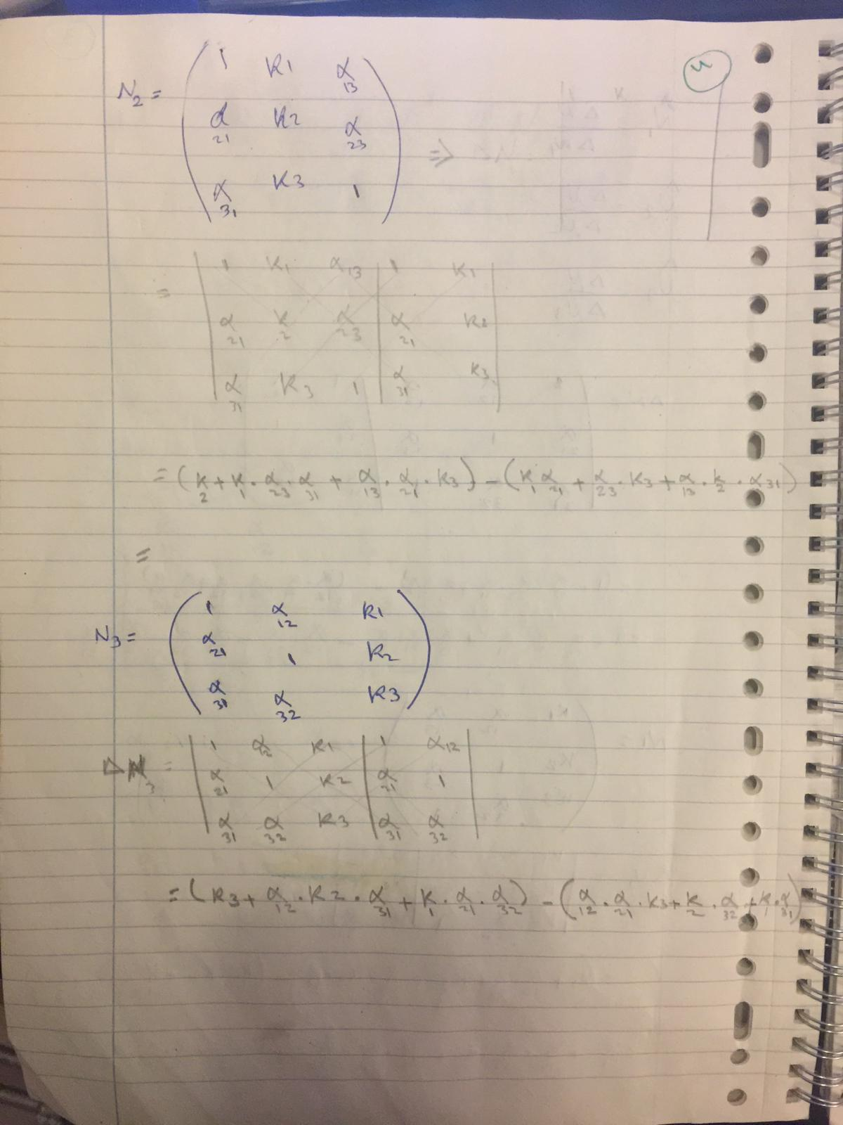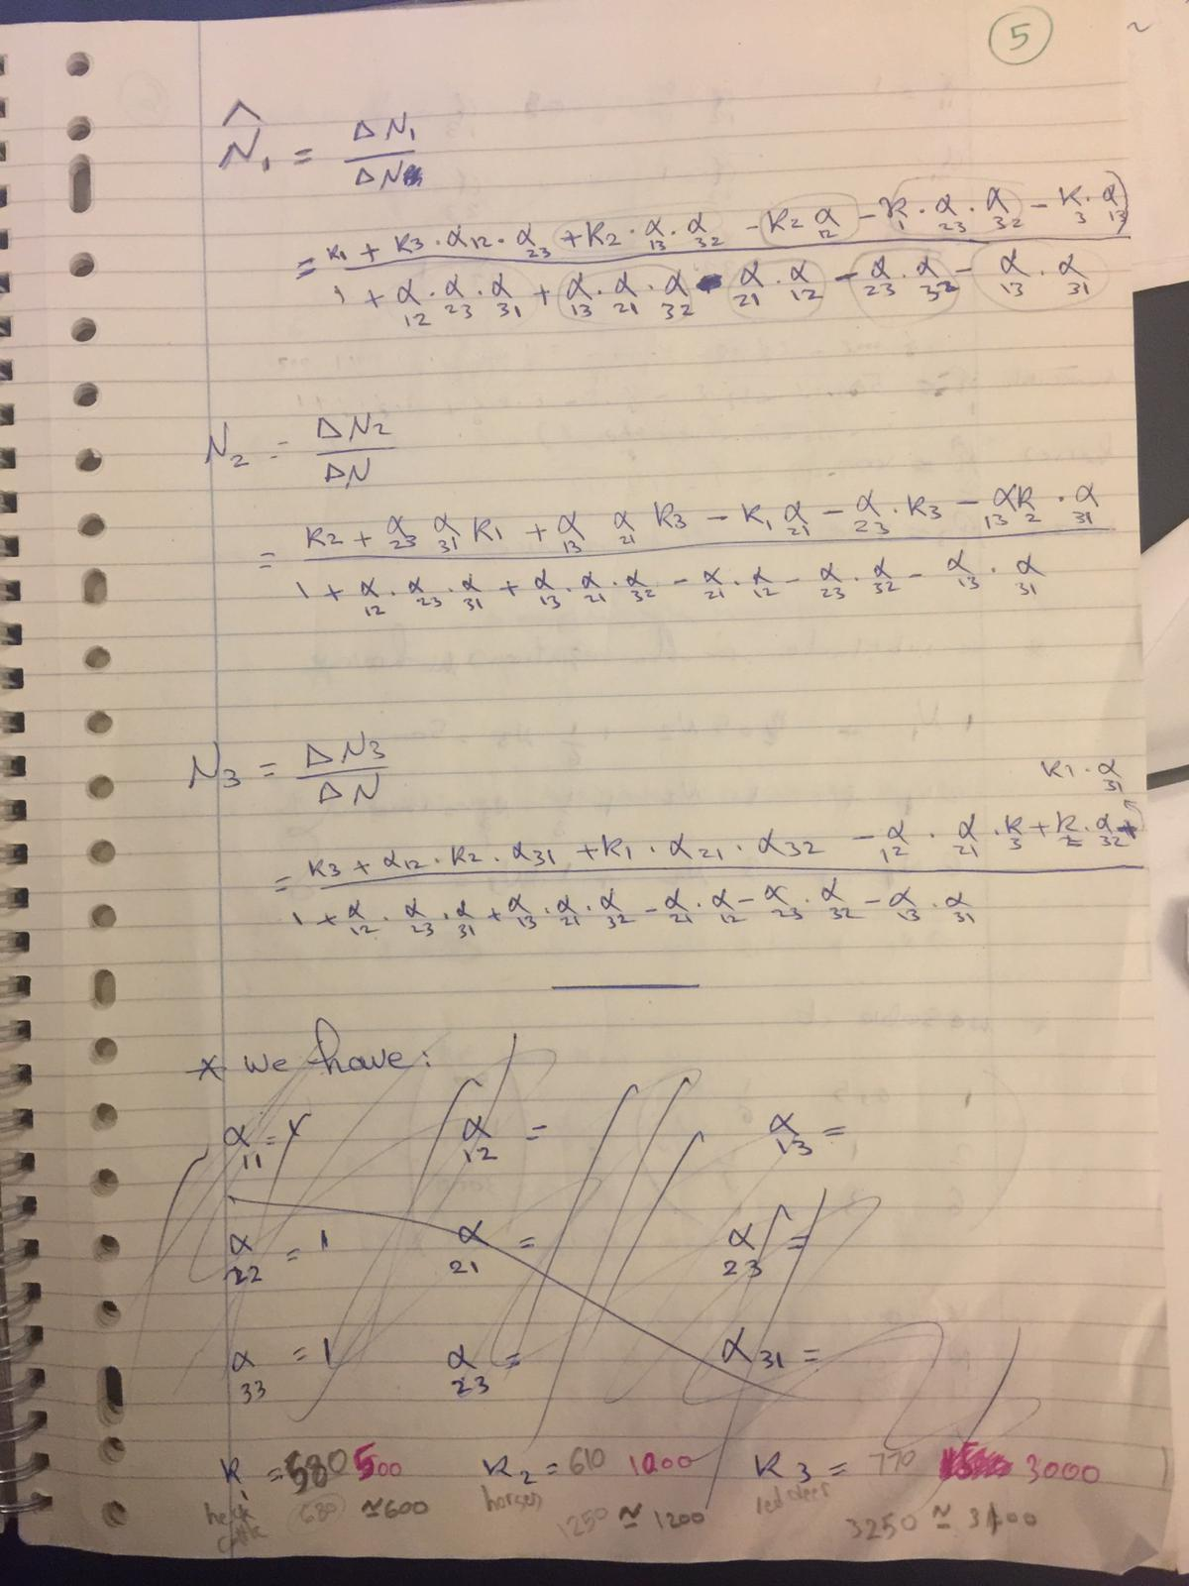 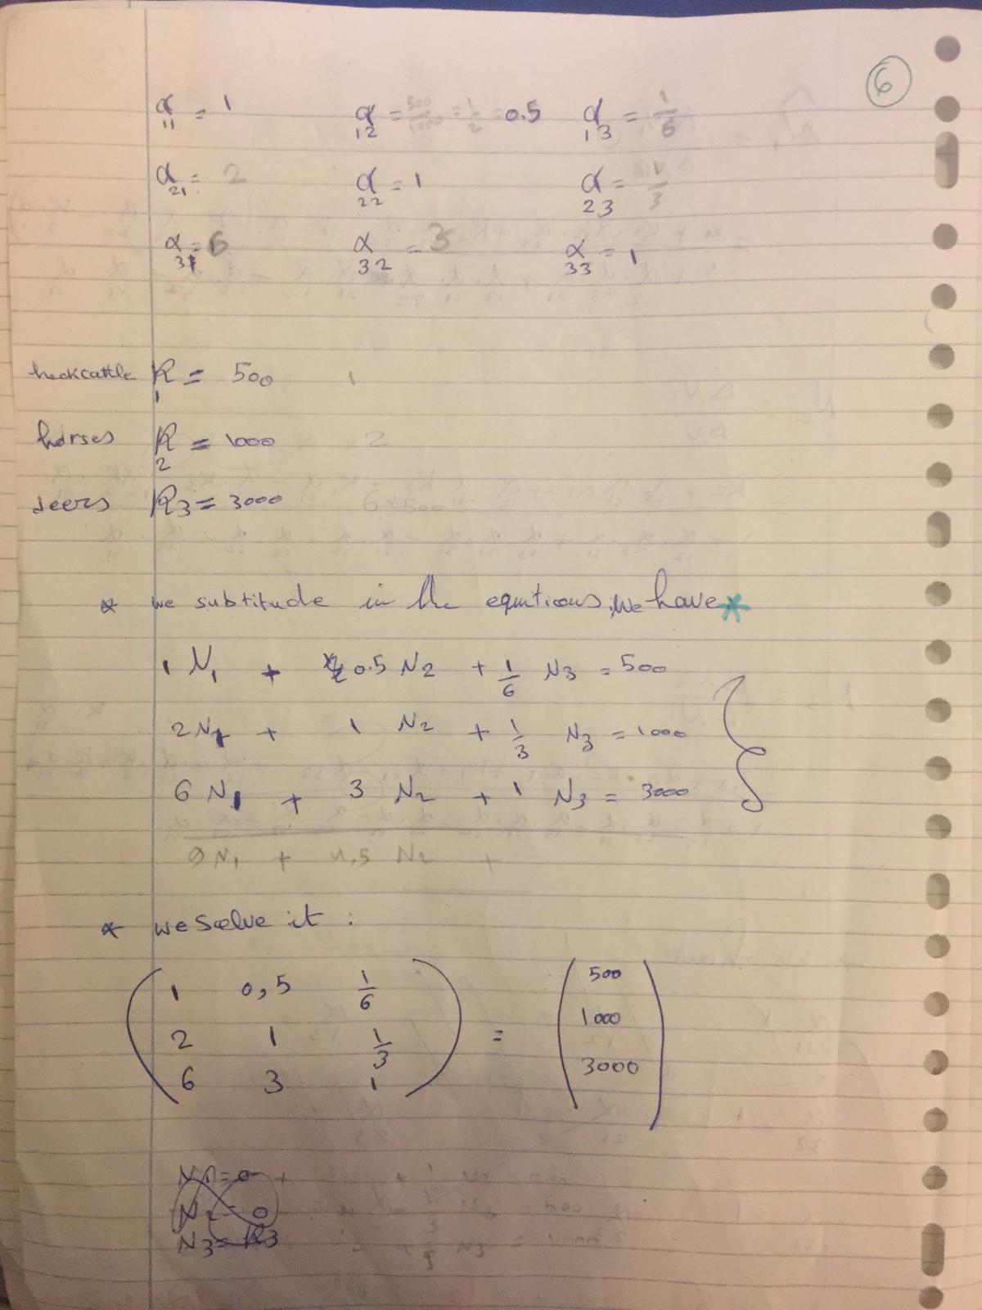 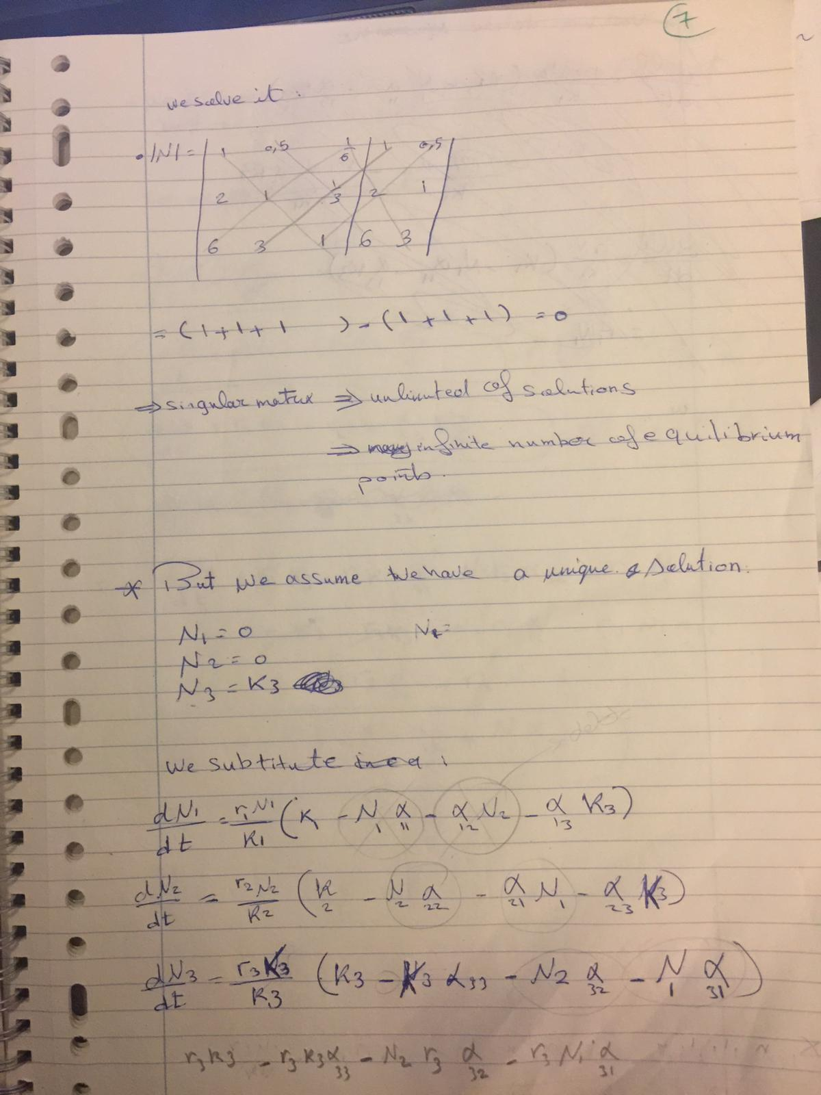 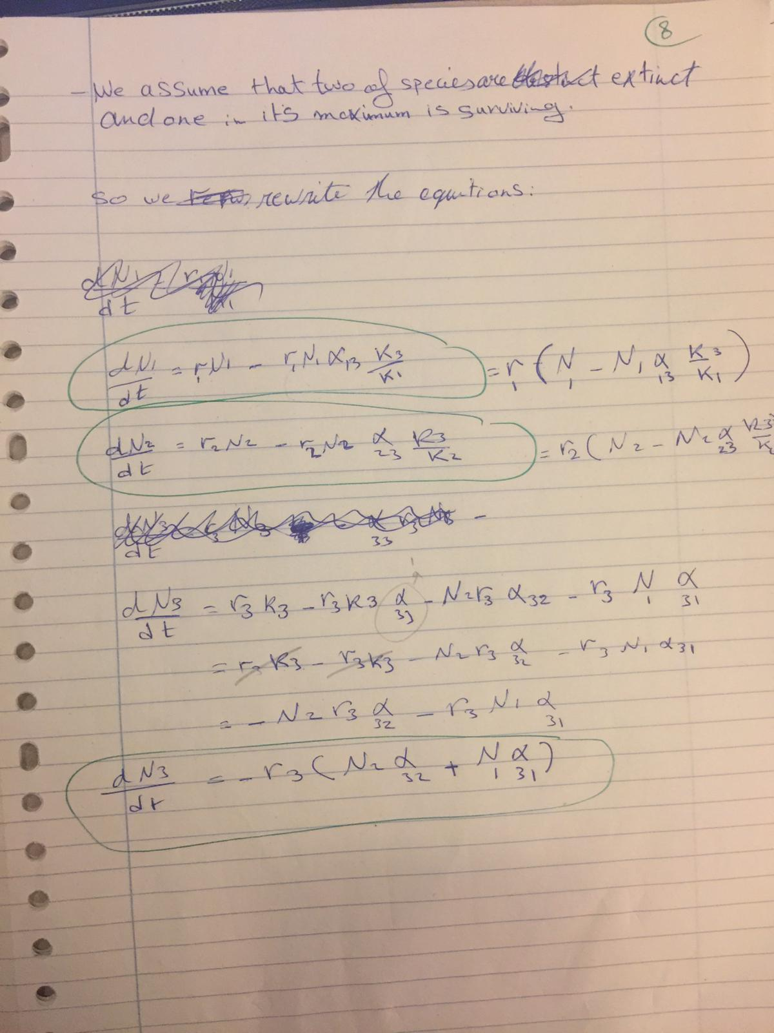

# Appendix D

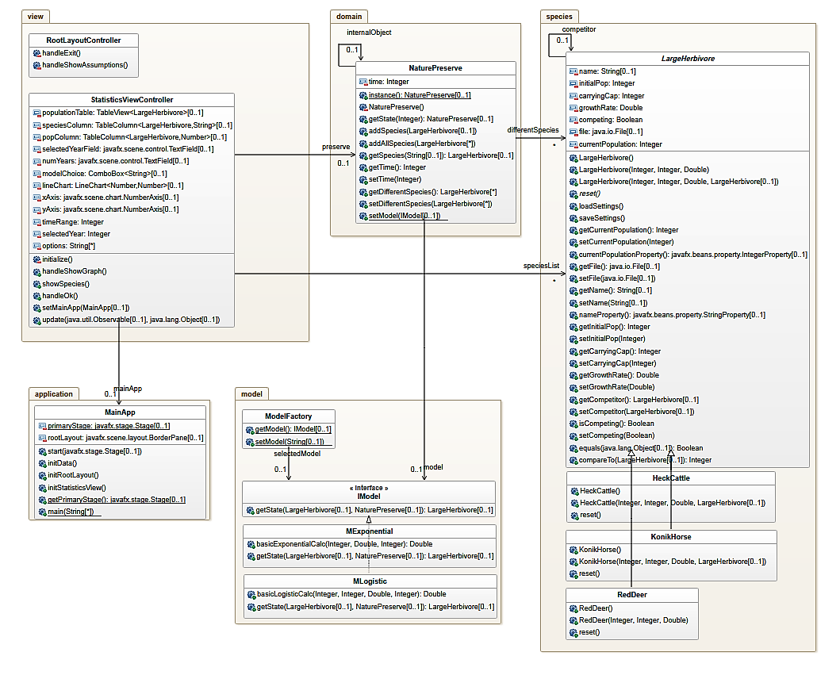**Application Class Diagram**